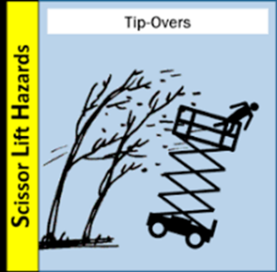

**High Wind Hazards**

Struck-by incidents due to objects being blown around.

Slips, falls, and trips from materials blown around.

Eye injuries due to small particles of flying debris and dust

Dropped loads while completing lifts with wind present

Objects falling from elevated surfaces

Tip-Over of elevated work platforms/scaffolding

Falling off work platform/scaffolding/roof and in need of rescue

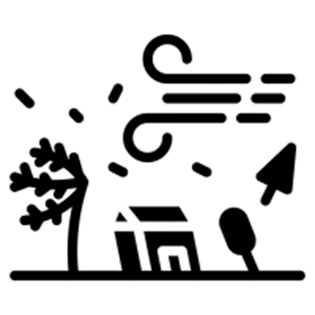

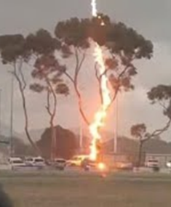

**Lightning Safety**

Lightning may strike as far as 10 miles from any rainfall. If you can hear thunder, you are close enough to be struck by lightning.

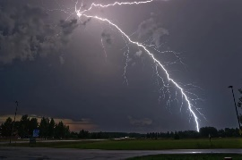

**Decrease your chance of being struck by lightning If caught outside during a thunderstorm.**

Stay low to the ground

Avoid being the tallest object around in a thunderstorm

Stay away from bodies of water

Water is an excellent conductor of electricity

Stay away from trees

Standing under a tree is the second leading cause of lightning fatalities

Stay alert when working outside on roofs, ladders, in large open areas or adjacent to a large body of water if a thunderstorm is approaching.

**If you see lightning, check-in with your supervisor – it may be possible to pause work.**

**Tropical Storms & Hurricanes**

**Storm Damage & Cleanup**

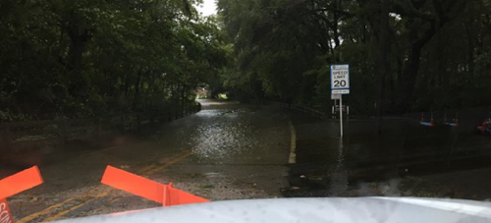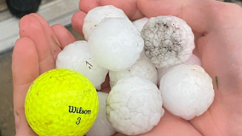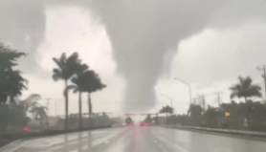

**Common hazards post-storm include:**

Flooded roadways

Saturated/Unstable ground

Downed powerlines

Downed trees/branches

Displaced wildlife

Non-functioning traffic signals and street lighting

**Scan code to view OSHA – Lightning Safety When Working Outdoors**

* Take safe, protective actions that mitigate or reduce hazards in your buildings and areas.
* Stay informed of the latest weather alerts by subscribing to receive UF Alert or from other trusted sources.
* The University of Florida homepage serves as the official source of emergency information and will be updated as necessary during an incident.

**Scan code to view University of Florida – Emergency Management webpage**

Hazardous conditions may still be present even after a storm passes.

Assess each situation and approach with caution before work begins.

Potential for tornadoes and hail-producing thunderstorms increases during tropical storm season

All types of severe weather can be expected with the arrival of a tropical storm or hurricane.